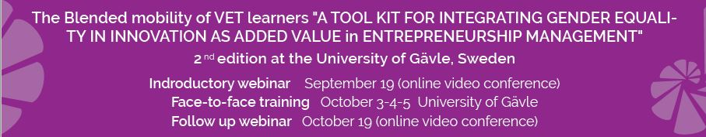

Participation form

Name and Surname
Day of Birth | ____/____/______
Country
Email
Organisation
Role
Destination | Winnet Sverige – Gävle, Sweden:  Distance Introductive Webinar: 19th September  3 Days of In-Class Training: 3rd - 4th – 5th October  Distance Follow Up Webinar: 19th October

I authorize the processing of my personal data according to the Legislative Decree no. 196/2003 "Personal Data Protection Code”.

Aware of the consequences of making false statements, falsehood of acts and use of false facts, punishable by law according to art. 76 D.P.R. n. 445/2000, under my own responsibility, I declare that all the information reported in the CV provided is true and correct.

Place and date Gävle, Sweden 17 August, 2017

Signature

_______________________

IMPORTANT!

Each participant will need to attend the 5 days training activity:

Distance Introductive Webinar: 19th September
+ 3 Days of In-Class Training: 3rd - 4th – 5th October
+ Distance Follow Up Webinar: 19th October

Please send your curriculum vitae and the participation form attached to:

Organisation name: Winnet Sverige.
Contact Person: Mrs. Britt-Marie Söderberg Torstensson
Email: britt-marie.torstensson@winnetsverige.se
Phone n.: 026 65 27 66

